**Lab 3: Equivalent Resistance**

**Objective:**

To understand equivalent resistances for series, parallel, T, and π resistive networks.

**Equipment and Components:**

1. Resistors: 3.3 k Ω, 6.8 kΩ, 15 kΩ

2. DC power supply

3. Digital multimeter

**Preliminary:**

1. Calculate the equivalent resistance for the circuits in Figures 3.1 and 3.2. Calculate the voltage drop across and the current flowing through each resistor.
2. Utilize equivalent resistances to solve the circuit in Figure 3.3. Determine the voltage drop across and the current flowing through each resistor.
3. Calculate the resistance between the terminals Rab, Rac, and Rbc for the T circuit shown in Figure 3.4.
4. 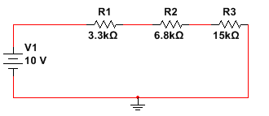Calculate the resistance between the terminals Rab, Rac, and Rbc for the π circuit shown in Figure 3.5.

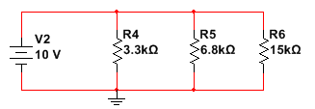Figure 3.1: Series combination Figure 3.2: Parallel combination

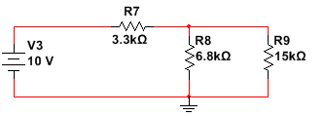

Figure 3.3: Circuit with series and parallel resistors

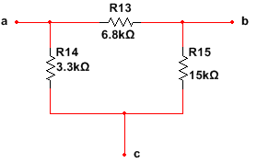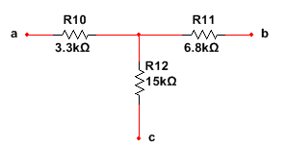Figure 3.4: T network Figure 3.5: **π** network

**Procedure:**

1. Build the circuit in Figure 3.1. Measure the voltage drop across and current through each of the resistors.
2. Build the circuit in Figure 3.2. Measure the voltage drop across and current through each of the resistors.
3. Build the circuit in Figure 3.3. Measure the voltage drop across and current through each of the resistors.
4. Build the T circuit in Figure 3.4. Measure the resistance between the terminals Rab, Rac, and Rbc.
5. Build the π circuit in Figure 3.5. Measure the resistance between the terminals Rab, Rac, and Rbc.

**Conclusions:**

Discuss the lessons learned from this lab. Determine the % error between the calculated values from the preliminary and the measurements you made in lab, and include in one summary table. Explain any significant discrepancies.

**% error= 100*(Calculated Value-Measured Value) / (Calculated Value)**